**CREATING IBM CLOUD SERVICE**

|  |  |
| --- | --- |
| **Date** | 26 OCTOBER 2022 |
| **Team ID** | PNT2022TMID05953 |
| **Project Name** | GAS LEAKAGE MONITORING AND ALERTING SYSTEM FOR INDUSTRIES |

**MEMBER 1 : DHANYA U**

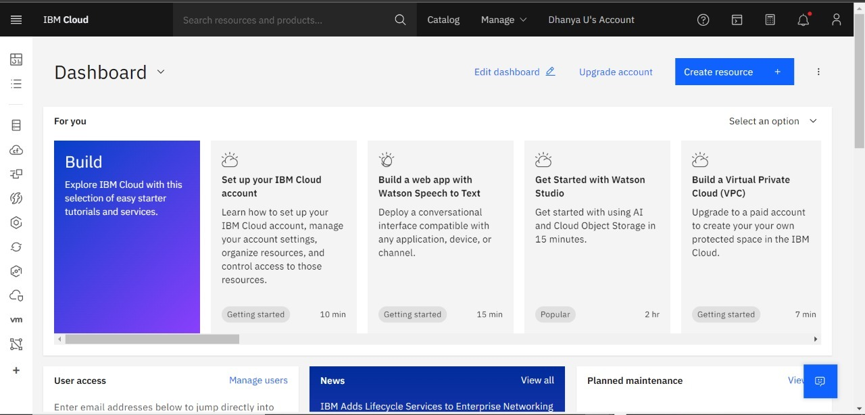

**MEMBER 2 : GURUTHEEP M**

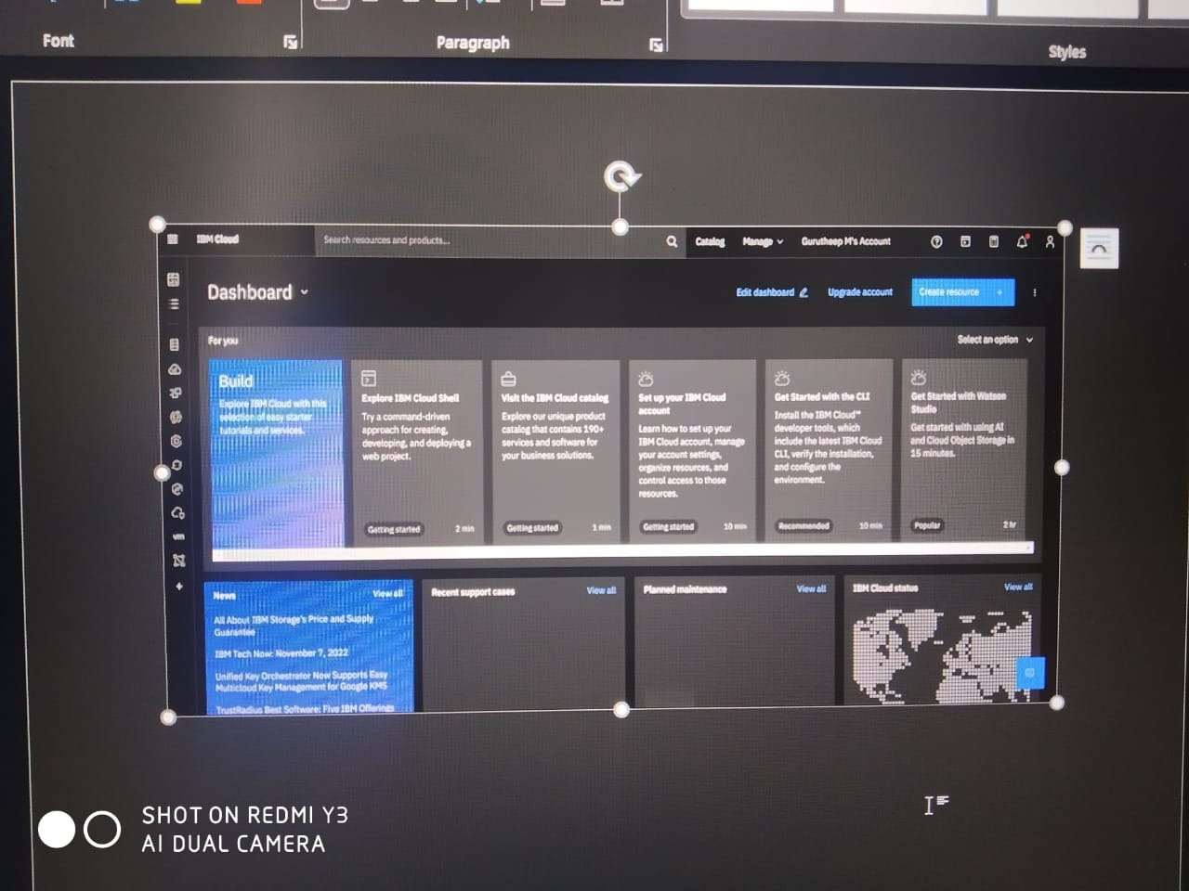

**MEMBER 3 : DHARANESHWARAN S**

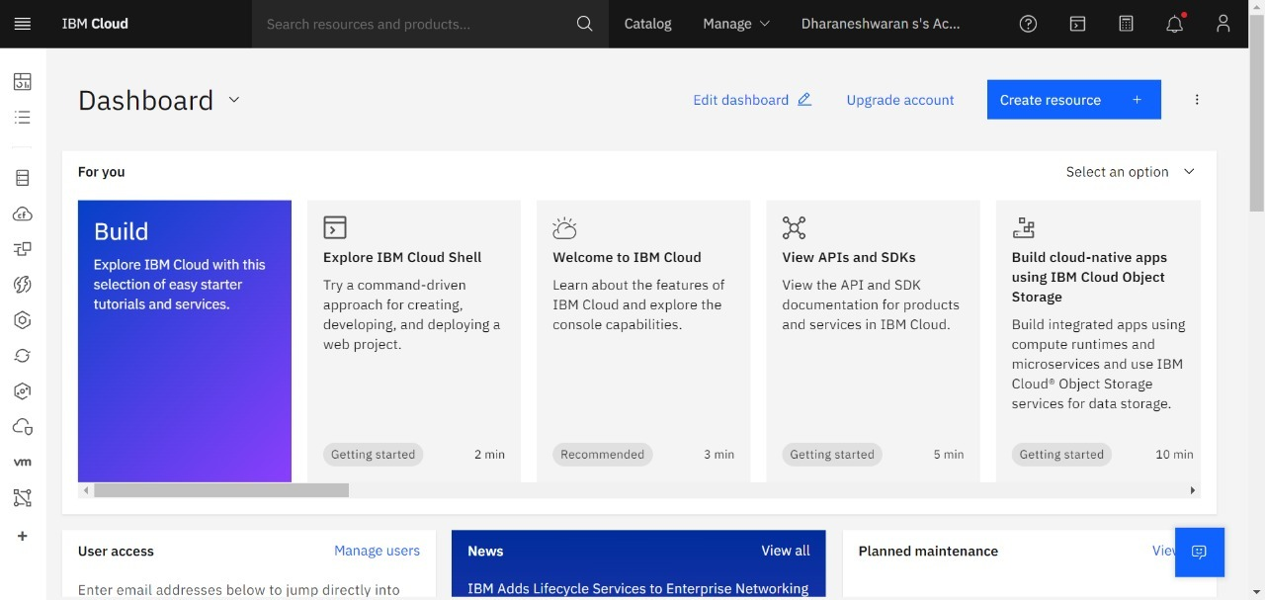

**MEMBER 4 : RANJITH R**

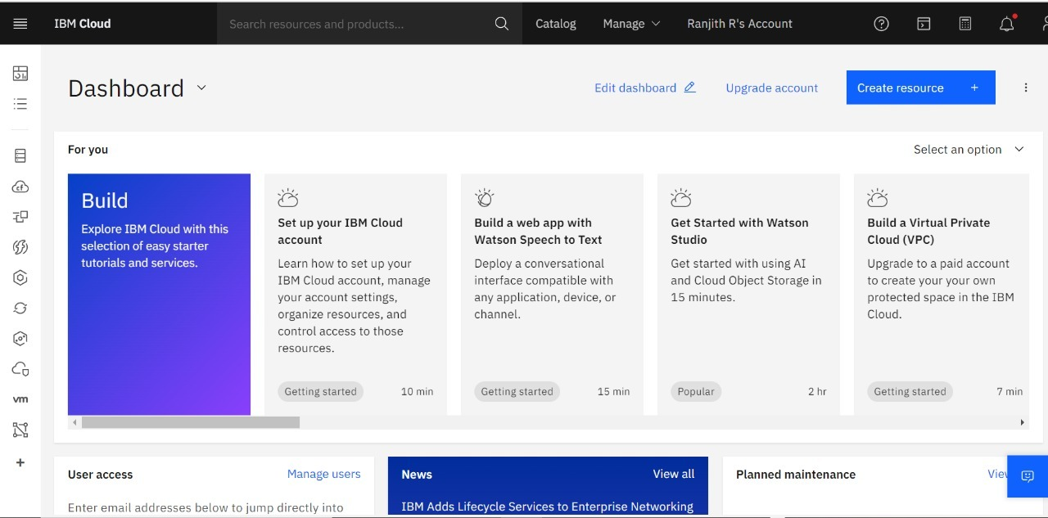

An IBM Cloud Service created Successfully.